Control System Design of Battery Charge Regulator Used in Spacecraft

Abstract: A power control unit (PCU) for space power control based on Superbuck circuit topology is proposed.

The design method of the control system of the Battery Charge Regulator (BCR) is introduced. The basic structure of the PCU

And the basic principle of control area division, the operation mode of BCR in PCU system is analyzed. According to its operating characteristics,

Perbuck circuit for the topology of the BCR was modeled, given the duty cycle control of the transfer function of a number of variables expression,

The three-ring parallel control of the battery charge regulator, and gives the BCR cut in the constant voltage output, constant current output, since the stable input of the mother

The simulation and experimental results under line conditions verify the correctness of the design.

Key words: Superbuck; charge regulator; constant current charging; constant voltage charging

Power Conditioning Unit (PCU) Is an important part of the spacecraft, is provided by space vehicles The normal operation of the power required for the core unit. Its function is to achieve will The solar energy carries on the photovoltaic conversion into the battery charge, provides the electricity for the load Can, and in less light or heavy load when the battery discharge security Card bus load normal work. In accordance with PCU bus voltage range Can be divided into three categories: no adjustment, semi-regulation and full regulation system. In recent years The widely used PCU system uses the latter two adjustment methods [1-2]

By the shunt regulator (Shunt Regulator, SR), battery

Charge regulator (Battery Charge Regulator, BCR), power storage

Battery Discharge Regulator (BDR)

Three parts constitute the old. 6j. The external VI generally include: solar cells

Board, battery, bus load and host computer communication interface.

BCR part can have a variety of circuit topology options, such as

Buck, Superbuck, BuckAmmt and the like. The Superbuck circuit has

Input and output voltage of the same polarity, the main circuit device is relatively simple, input

The output current is continuous, the current ripple caused by the bus and the battery

Small, etc., in the PCU system has been applied 17-8]. In addition, may

To further reduce the input by way of two inductive coupling in the topology

Output current ripple â '¢, reduce the volume. In addition, Superboost extension

Flutter with boost, power density, input and output current continuous excellent

Point, suitable as a BDR topology choice, with Superbuck

The integrated circuit is designed as a bi-directional converter, as a unified battery charge

Discharge module 111-13], and thus has a large application prospect.

[9,11,14-15] describes the base of the Superbuck circuit

The principle and small-signal modeling, described in [7-8] Superbuck

As part of the BCR in space applications. The author of this article

42 V full regulation bus PCU system, for example, the PCU system

The operation of each module part of regulation, focusing on analysis of the Superbuck

Circuit topology in the BCR case as a fully regulated bus PCU system

Model and its corresponding output model, and as a basis to solve

The switching problem of BCR control loop logic under various output conditions is discussed

And the steady-state operation of the conditions required by the controller design.

Analysis of System Operating

Figure 1 shows a schematic diagram of a fully regulated bus PCU system, including

Shunt regulator (SR), battery charge regulator (B (, R), power storage

Discharge Discharge Regulator (BDR). SR is the solar panel to the bus

Channel, in order to sunny enough to return to the excess current of solar energy

The panel stabilizes the bus voltage. BCR is the bus-to-battery charge

Channel, for the battery charging, in the different structure of the PCU, there

The BCR alone stabilizes the bus voltage and does not participate in the stabilization of the bus voltage

Working mode. The BDR is the discharge path from the battery to the bus

To provide a stable bus voltage when lighting is poor.

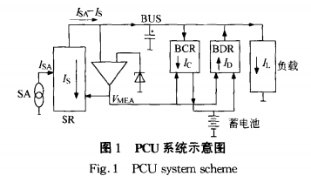

When the satellite is in a well lit environment, the solar panels are powered Flow jsA greater than the required load current and battery charging current, the Department System work in the SR domain, the excess current bypass shunt back to solar energy Panel, this time JfsA = Js + jc + IL; consider BCR participation in stability The bus, when the current JSA is greater than the load current required, but less than the load And the sum of the required current of the battery, the shunt regulator SR stops Flow, the system works in the BCR domain, BCR adaptive to reduce the input power Flow to ensure bus load current unchanged, to maintain bus voltage stability, this time

When the system is operating in the light, there is J = A (J: + h, shunt current, s = 0; According to insufficient conditions, the current sA is less than the load current required, that is, JsA <", The system works in the BDR domain, BDR discharge to the battery To ensure bus stability, this time jsA + fD = IL; when there is no light, The system only relies on the battery discharge to provide the load required current to maintain the mother Line voltage is constant, then IsA = 0, Jd_II ,. The PCU uses the outer loop voltage controller to obtain the master given by the inner loop Error amplifier (Main Error Amplifier, MEA) signal, The MEA value reflects the size of JsA-h. On the MEA signal (SR domain, BCR domain, BDR domain) in the PCU system Domain) control diagram shown in Figure 2. Where point A corresponds to the BDR domain High power point, point B corresponds to the shunt regulator maximum shunt power point.

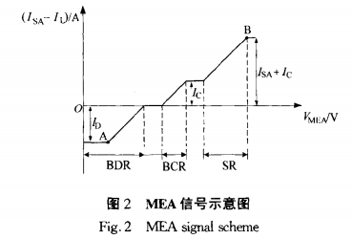

This article discusses the battery charge regulator need to have three functions:

①Constant output voltage charging mode;

② constant output current charging mode;

③ self-stabilizing bus voltage mode.

Constant voltage and constant current mode appear in the system

Work in the SR domain, then BCR as the load, the bus voltage to rely on

SR, and the BCR input is equivalent to the ideal voltage source

Signal will not affect the constant voltage and constant current settings; self-stabilizing bus power

Pressure mode is the system work in the BCR domain, MEA signal will be controlled

The BCR input current is used to stabilize the bus voltage.

Superbuck Circuit working principle and model

Figure 3 shows the independent inductance configuration without considering spurious parameters

Superbuck circuit topology, the topology includes two switches, Q,

Denotes a MOSFET switch tube, and D denotes a diode. The input side of the deposit

Inductor L1, and thus the input current is continuous. The output current is two

In the CCM mode, Q1 and D1 alternate conduction

Pass, so the output current will be continuous.

When the Q1 turn-on, D1 cut-off, the inductor current iLl, iL2 increase,

Output current. . As the sum of the two inductor current, and thus increase; when Q1

Cut off, D1 conduction, the inductor current iLl, iL2 decreases, the output current

Then decreases. Write the state square for the circuit topology shown in Figure 3

Cheng tame, available

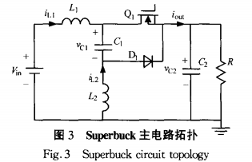

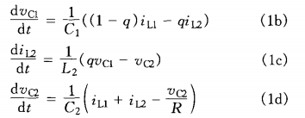

Where: q that switch state; q = I said switch conduction, Pi = 0

Said switch off. The state variables in the above equations are carried out for weeks

Period, the steady-state inductor current and the DC voltage of the capacitor voltage

Expression

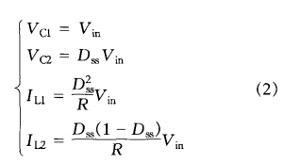

Separate disturbance variables and linearization and simplification of state equation After the small signal expression is as follows

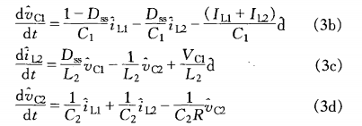

Ignoring the input voltage disturbance i. , Under the direct control of the duty cycle

Of the Superbuck circuit of the linear model matrix equation

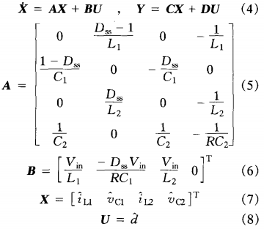

Where: D. Is the steady-state duty cycle; R is the load resistance. According to the output moments

Different from the array C, you can build the output voltage Z '/ out input current ii. , & Lt;

Output current Z: out of the duty cycle a transfer function.

BCR module control

Figure 4 shows the BCR module with Superbuck circuit topology Control System Schematic. Where A is the outer loop controller, and PCU is generated

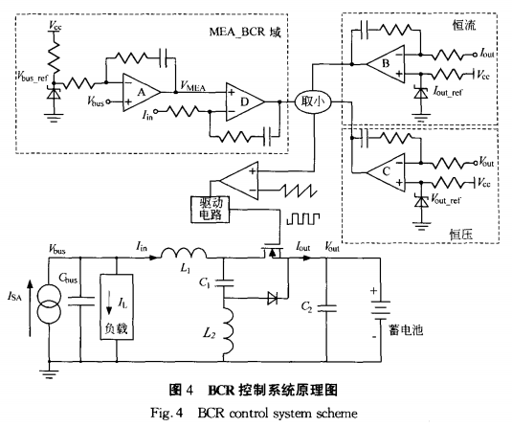

When the system is operating within the BCR domain, the MEA signal acts as a BCR

The input current is given, ie, the inner loop controller is given as D, such that

Input current without tracking error MEA instruction, controller B, C respectively

Output constant current and output constant voltage controller.

If the MEA signal is in the BCR domain, the controllers B and C are saturated

And, at this time although the battery is in a state of charge, but fail to achieve constant voltage output

Out setting or constant current output setting. When the battery is gradually full, the voltage

Rising to constant voltage setting or charging current rising to constant current setting

Value, or the solar panel current JsA gradually increases, the bus load

Decreases the MEA signal.

When the battery input current or voltage reaches the set value,

The controllers B, C are de-saturated and the controller D goes into saturation, MEA

The signal increases, enter the SR domain, the system relies on SR to maintain the bus

The voltage is constant. Therefore, the BCR part of the controller B, C role is right

The MEA signal operates in the BCR domain to perform interval limiting.

Because the output constant voltage and output constant current set value is variable, so BCR lose

The input current does not necessarily reach the maximum input current into the SR domain.

When the system actually works in the BCR domain, the MEA signal and BCR output

The curve of the incoming current is shown in Fig.

In order to make BCR module in constant voltage constant current and system running BCR domain can be stable when the operation, the need for three sets of controller set To ensure system stability, including constant voltage, constant current mode of operation Is to achieve the battery charging, so its dynamic performance requirements are more Broad. For the inner loop controller D, it needs to adjust the speed faster, In order to meet the dynamic performance requirements of the outer loop controller A. Fig. This is because At this time the bus voltage is controlled by the BCR to determine its input current, so The dynamic performance of the bus has a decisive role in quality.

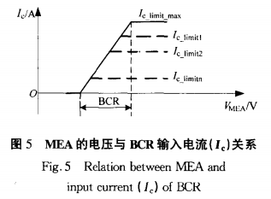

**4 Superbuck circuit design**

**4.1 constant voltage controller design**

Taking into account the input current ripple and output voltage ripple and volume limit , The main circuit parameters selected L1 = 250 tzH, L2 = 110 /, H, C1 = 2.5 F, C2 = 10 / * F, this set of circuit parameters make the output voltage Is 32 V and the system operates at half load 10%, the output voltage ripple is 0.4%. The average is obtained by the cycle The transfer function Gvod (s) of the output voltage to the duty ratio is

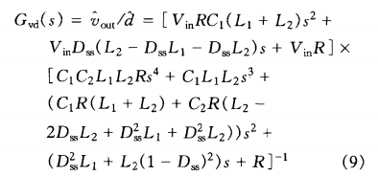

BCR control block diagram of constant voltage output mode shown in Figure 6, Where Gcv is the controller, ‰ is the amplitude of the triangle wave, and Kvs is the voltage Sampling factor.

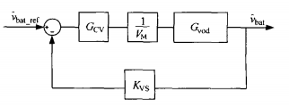

Figure 6 constant voltage mode system block diagram

The output voltage is selected as 26 V, 32 V, 38 V, half of the converter

The operating conditions (125 W) were used as a stable operating point to obtain an uncorrected system

The Bode plot is shown in Figure 7.

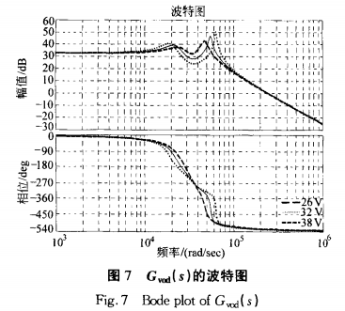

Because the system requires a wide range of variable output voltage requirements

And the system itself has dual conjugate poles and RHP

Of the conjugate zero point, light-load resonance case will gradually highlight the peak, through

In the capacitor C, both ends of the parallel RC absorption circuit to ensure that the system in the light

Load-time stability, reduce the light-load conditions under the resonant peak amplitude

Value [16-17]. Taking into account the battery voltage changes are relatively slow, swap

Section system is not demanding fast, so the controller Gcv proportional product

Sub-controller, reduce the system cut-off frequency to ensure stability, get school

Positive system loop gain (TCv = GCvGvodKvS / V)

Figure 8 shows the cut-off frequency.

**4.2 constant current controller design**

The transfer function of the output current to the duty cycle is obtained by means of the period averaging

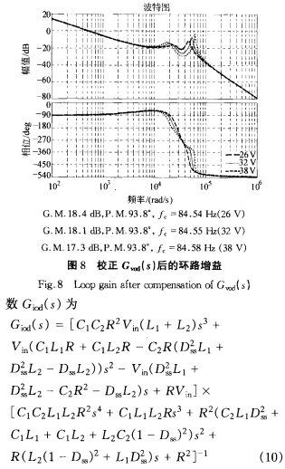

Constant-current mode BCR control block diagram shown in Figure 9, Gcc is

Controller, VM for the triangular wave amplitude, Kcs for the current sampling factor.

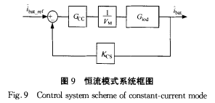

The selected output voltage is 26 V, 32 V, 38 V, and a power of 125 W as a steady-state operating point, the uncorrected system Bode diagram shown in Figure 10. As the system needs constant tracking variable output constant power Flow set value, so the controller Gcc PI controller for the system , And the corrected system loop gain is obtained (Tcc = GcvGiOdKcs / V. The Bode plot is shown in Figure 11.

**4.3 Design of Dual Loop Controller for Stable Bus**

Voltage Field When BCR works in the stable bus voltage domain, this time BCR The circuit is controlled by double-loop, and the outer loop is unified by PCU system Bus voltage loop, the inner ring for the BCR input current loop, by adjusting the input Into the current to achieve a constant bus voltage to maintain the required load current unchanged,

The system block diagram shown in Figure 12.

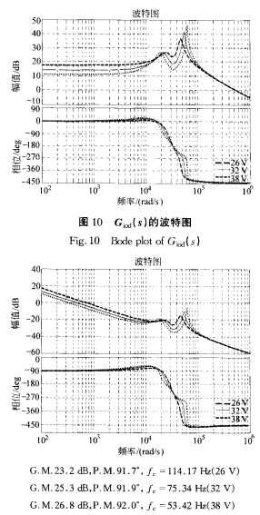

Fig．1 1 Loop gain after compensation of G磷(S)

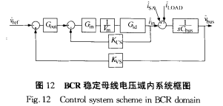

In Fig. 12, G. . For the PCU system voltage outside the ring controller, the mother The difference between the line voltage feedback value and the given value is taken as the outer loop controller Internal loop reference, ie BCR input current reference. Gi. For the inner control Device, V. For the sawtooth peak, GId is the BCR input current to duty The transfer function, K (s is the BCR input current sampling factor, Cb. For the bus capacitance value, Kvs for the bus voltage sampling factor, sA For the solar panel output current perturbation, iLOAD is the load current disturbance move. It should be noted that the load on the busbar is mostly resistive load The bus load varies widely, so it is negative for different buses

The 1 / sCbuS entry in the system block diagram should be rewritten as

Rbu. / (5Cb.Rb. + 1), it is easy to see the bus load disturbance and so on

The effect of load current disturbance only affects the system loop gain at low frequency

, Does not affect the high-frequency characteristics, so here the bus load disturbance model

Equivalent to the load current disturbance, simplify the system loop model.

Superbuck circuit input current pairs are averaged over the period

The transfer function Gid (S) of the duty cycle is

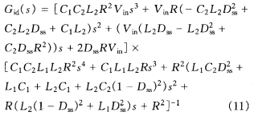

According to BCR output voltage 26 V, 32 V, 38 V, power point

125 W was chosen to carry out the static analysis of the working point,

The positive system Gid (S) Bode plot is shown in Fig. Using PI controller

As Gi. To obtain the corrected inner loop of the system

(Ti. = Gi.GidK. / V.) The Bode plot is shown in Fig

The closed-loop transfer function of the inner loop is

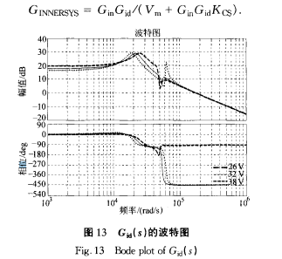

It should be noted that the corrected object Gid (S) is in this process There will be U {P zero migration to the RHP situation, so Bode diagram There is a phase-frequency characteristic inconsistency. The transfer function of the inner loop is controlled not only by the triangle wave modulation control system Steady-state operating point, but also by the controller and the current sampling factor shadow ring. Ignoring the effects of iSA and iLOAD, correct the inner loop in Figure 14 Loop gain based on the design of the outer ring controller G training, get BCR The outer loop loop gain (T .. = G) in the stable bus voltage domain. GINNERsYsKvs / sCb. . The Bode plot is shown in Figure 15.

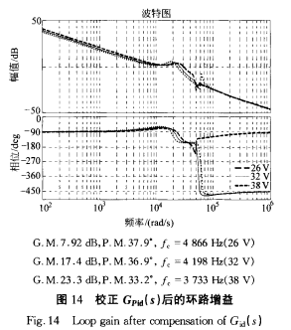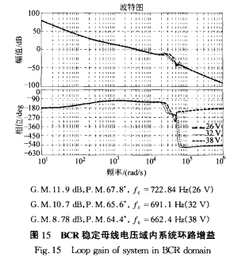

**5 Simulation and experimental results**

The simulation results and experimental results are validated respectively. Simulation software PSIM to build simulation platform, bus capacitor array Take 2 mF, respectively for the following four kinds of conditions for simulation:

1) constant voltage mode. Bus voltage is stabilized by the SR at 42 V, BCR output voltage 32 V, the output current step from 4 A to 8 A. this When the controller B, D in Figure 4 saturation.

2) constant current mode. Bus voltage is stabilized by the SR at 42 V, BCR output current 4 A, the output voltage step from 26 V to 38 V. At this point in Figure 4, the controller C, D saturation.

3) constant current switching constant voltage mode. The bus voltage is stabilized by SR 42 V, constant voltage setting 35 V, constant current setting 6 A, BCR output load Step from 5 Q to 10 Q. At this point the controller D in Figure 4 saturation.

4) Self-stabilizing bus voltage mode. The bus voltage is stabilized by BCR

Set at 42 V, the solar panel output current is 8 A, B (, R)

Load 4.4 Q, bus load step from 1 A to 5 A. Figure 4 at this time

In the controller B, C saturation.

Figure 16 shows the simulation result waveform, V. . . And V. . Bc, are said

BCR output voltage, f. . Represents the output current of the BCR, Jin bc,

Indicates the input current of the BCR, Vb. Indicates the bus voltage.

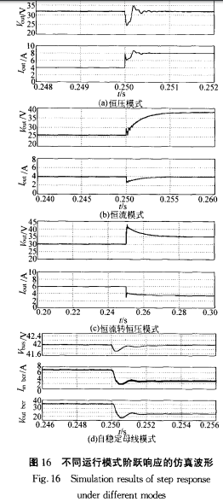

The experimental results corresponding to the simulation results are shown in Fig. each

The experimental conditions for the modal conditions are the same as those for simulation.

The above experimental results show that BCR can work stably

Voltage, constant current and self-stabilizing bus voltage in three operating modes, each transport

The BCR has good step characteristic in the line mode, and the control system

The system can quickly achieve the battery charging process constant current mode and constant voltage

Mode conversion, has a good steady-state and dynamic performance.

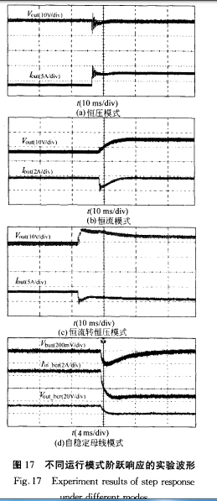

6 Conclusion

This paper introduces the basic structure and analysis of PCU system for space flight The operating mode of the BCR in a fully regulated bus type PCU system formula. Since B (R) needs to include output constant voltage charge, output constant current charge Electricity and self-stabilizing bus voltage three operating modes, and the various conditions The switching logic between modes is more complex, so with the various operating modes Corresponding to the design of the control loop and the control loop switching logic The relationship is also more complex. This is for the fully regulated bus type PCU system BCR function requirements and characteristics of the Super- Buck circuit as the BCR part of the topology, by analyzing the calculation does not A small-signal model with the output versus duty-cycle perturbation is designed Three-ring parallel control system approach to ensure the BCR in a variety of modes The stability of the operation of the closed-loop system and the correct mode switching logic . Through the simulation and experimental results, the paper validates the theoretical design Correctness.